Kafka Issue:

Class not found:

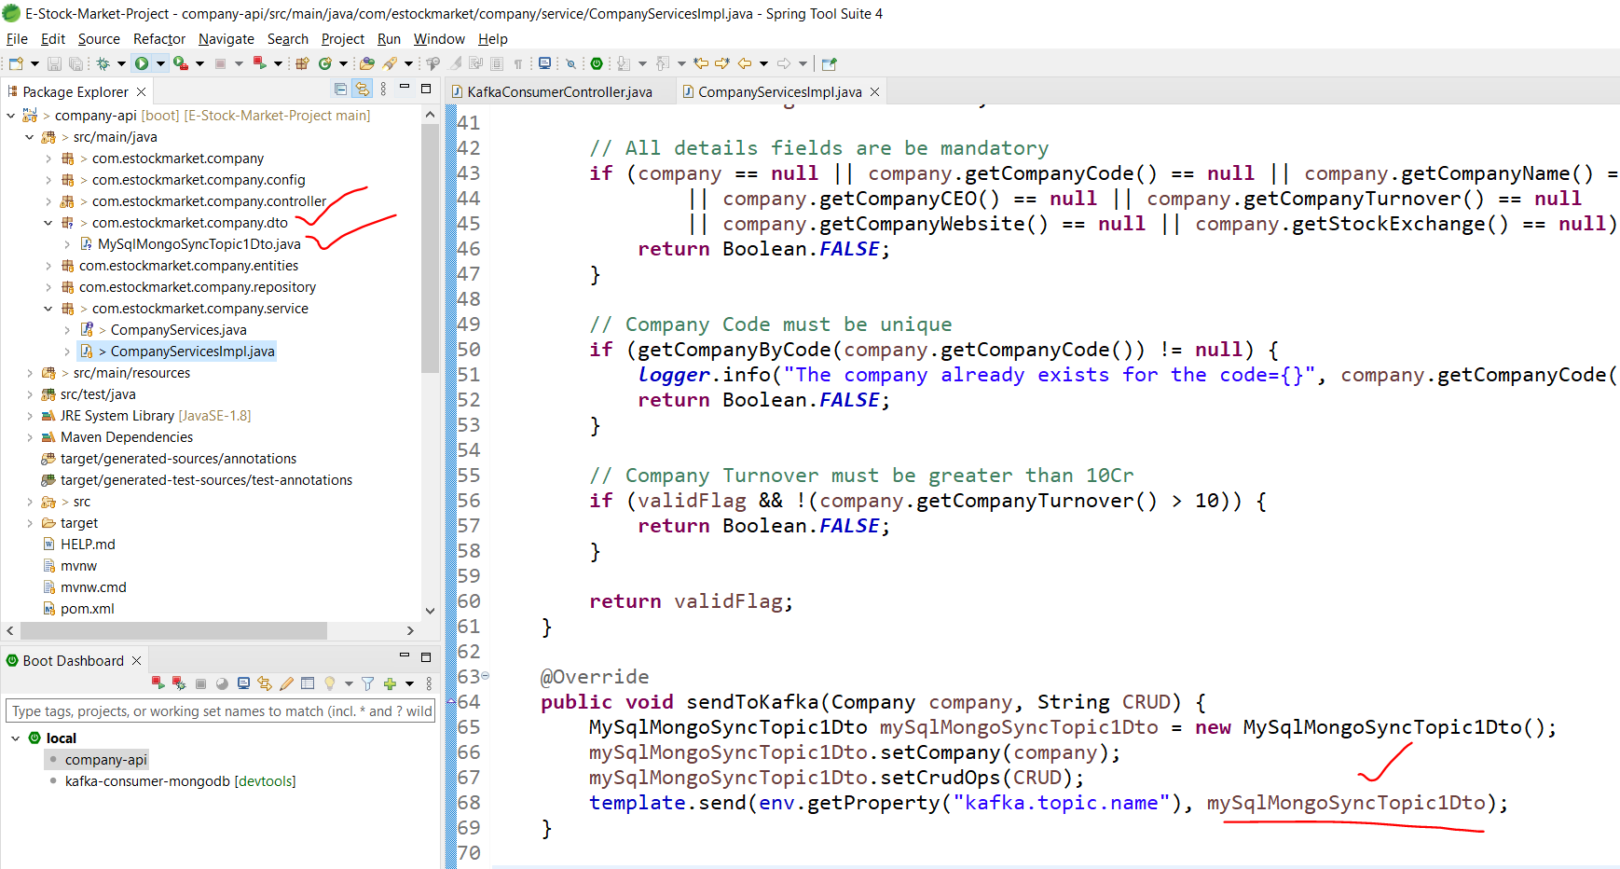

Producing this object to the topic.

So, the same package should be available in the consumer as well:

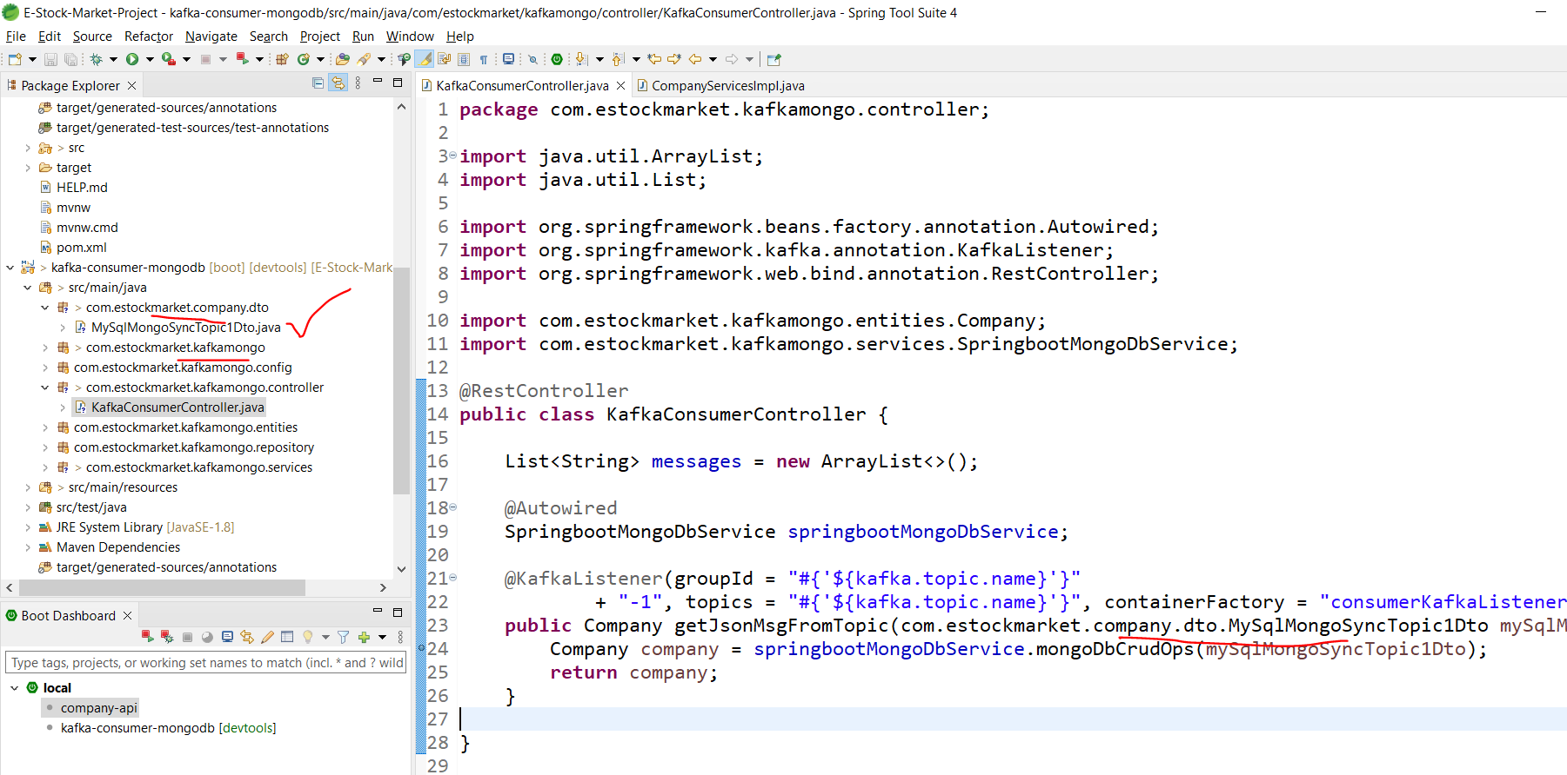

Note: This package and the base package of this project does not match though.